Intro histoire
The castle atop Hellknight Hill, Citadel Altaerein, has stood abandoned for years in eastern Isger—a legacy left behind by the Hellknight Order of the Nail that’s largely ignored these days by the populace of the nearby town of Breachill…

THE CALL FOR HEROES
Breachill’s local government has a long history of hiring adventurers to tackle challenges its residents face that fall outside the scope of the town guard’s duties. The merchant whose expected shipment of goods hasn’t yet arrived, the shepherd whose herd of goats mysteriously died in the night, the farmer whose entire season’s harvest was ruined or stolen—investigating and resolving any of these matters are considered good jobs for adventurers, and so Breachill’s town council uses its resources to hire heroes as needed. These monthly meetings, known as the Call for Heroes, are distinct from the council’s normal regular governance meetings, a tactic that separates such matters from regular municipal business and shows the townspeople that the council takes seriously the issues that are often most important to them personally

Breachill
The town of Breachill is nestled in the foothills of the Five King Mountains in the wilds of eastern Isger, about 50 miles from the Druman border. Compared to the region’s other settlements, this small town is young—just shy of 170 years old—though it has a fascinating history that rivals those of many far older places. Breachill began with the humblest of origins, as a barely functional outpost of human amnesiacs, but the aid and mentorship of a powerful wizard led these shivering and dying unfortunates to found the hardy and thriving town that exists today.
Many of Breachill’s 1,300 residents are humans who trace their ancestry to one of these original pioneers, leading to the townsfolk’s identity as people who persevere and are self-sufficient by birthright. As a result, the residents of Breachill are brave and community minded. Unlike the insular inhabitants of many Isgeri towns, they welcome adventurers of all types. After all, the townspeople owe their existence to the benevolence of a powerful wizard and adventurer—Lamond Breachton—whose legacy is so beloved that it is almost a religion. Practically without exception, any harsh words spoken in town against Breachton are taken as a challenge to most residents’ honor.
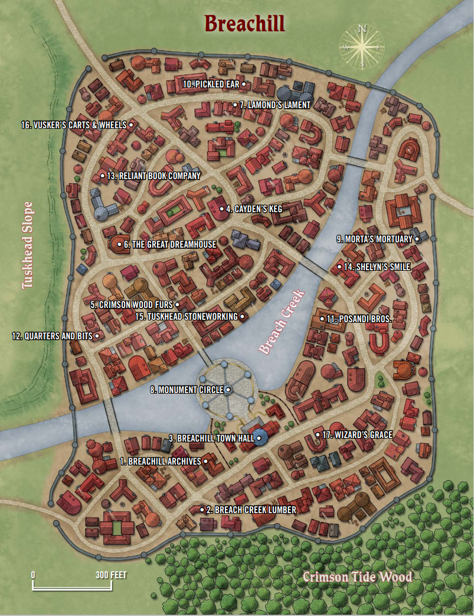

1. Breachill Archives
Kept in a sprawling (if musty) facility just across the fence from Breachill Town Hall, the town archives consist of official records and historical accounts dating back to the settlement’s founding. Chief archivist Jorell Blacktusk (male half-orc librarian) is one of the most knowledgeable citizens in the settlement about the town’s history. Jorell is happy to assist any visitors with finding even the most obscure records here, though the fact that he is woefully understaffed means that he is often preoccupied and distracted while doing so.

2. Breach Creek Lumber
This facility on the edge of Crimson Tide Wood serves as a logging mill and a carpenter’s shop. One of the largest logging companies in Breachill, the business provides lumber for much of the town’s construction needs and regularly sends contingents of lumberjacks into the nearby wood—though the aggressive boars, cougars, and even wargs and owlbears often make this a dangerous prospect. As a result, chief logging forewoman Narine Howerdell (female half-elf lumberjack) often hires adventurers to accompany these lumberjack teams. The associated carpenter’s shop employs some of the best artisans in Breachill; the eccentric Xandel Rynearsohn (male human carpenter) oversees it.

3. Breachill Town Hall
In addition to the chamber used for Breachill’s public meetings—including town council meetings and the Call for Heroes—Breachill Town Hall holds the offices of all staff members who support the town’s government and its myriad municipal functions, as well as facilities for its town guard and courts.

4. Cayden’s Keg
This rousing, well-kept tavern is one of Breachill’s most popular places to enjoy a hearty meal and a pint of ale, and it doubles as a temple of Cayden Cailean, the freewheeling Accidental God. The proprietor, primary bartender, and head priestess is Brynne Taithe (female human cleric of Cayden Cailean), who loves little more than when adventurers tell rousing tales of their daring exploits and deeds, preferably in conjunction with frequent purchases of ale.

5. Crimson Wood
Furs Despite the specificity of its name, Crimson Wood Furs is a comprehensive haberdashery known for its high-end tailoring, gorgeous cold-weather outerwear, and fine cobbling. The establishment takes pride in its origins as a luxury supplier to highranking Hellknights, and portraits of early Order of the Nail leaders wearing the shop’s fine clothes line the store’s mahogany walls. Current owner and chief tailor Winthrop Finney (male human tailor) is a relative newcomer to Breachill, but he is passionate about his craft and about outfitting his customers in exquisite finery.

6. The Great Dreamhouse
One of the few dedicated temples in Breachill, the Great Dreamhouse is a monastery-like establishment dedicated to the goddess Desna. About 30 priests and acolytes who live, work, study, and pray in the temple’s peaceful lounges and verdant indoor gardens call the place home. The Great Dreamhouse offers a place for weary travelers of all stripes to rest, and most of its resident faithful are willing to provide healing at a reasonable price. On clear nights in the summer, head priest Kellen Carondil (male elf cleric of Desna) invites the public into the temple’s observatory to gaze at the stars and ponder the callings of the goddess of travelers.

7. Lamond’s Lament
Located in one of the most hardscrabble parts of Breachill, Lamond’s Lament is a soup kitchen and place for the downtrodden to rest. The operation is funded through a mix of public money and donations, and its staff consists of volunteers from throughout the community. Renatta Gilroy (female human chef) currently oversees Lamond’s Lament. This quiet but deeply kind woman often helps guests of the operation at her own personal expense.

8. Monument Circle
This marble-paved circle is the visual centerpiece of Breachill. Around it stand six deep wells that the nearby residents and businesses rely on for fresh water. In the center of the ring is an elegant, 15-foottall bronze statue of the wizard Lamond Breachton, Breachill’s founder and the town’s most important historical figure.

9. Morta’s Mortuary
This imposing, black-painted building with heavy, onyx-colored curtains serves as the home and place of business for Morta Valaskin (female human mortician), an eccentric woman whose daily fashions include elaborate mourning gowns, gauzy black veils, and elbow-length satin gloves. Morta views death as both a business and a lifestyle. She is said to be one of the most informed gossips about town.

10. Pickled Ear
This rough-and-tumble dive bar and tavern is frequented by locals and hardscrabble adventurers alike—many of whom clash in rowdy and sometimes vicious brawls that take place far too regularly for the town guard’s liking. Proprietor Roxie Denn (female human tavernkeeper) is always looking for ways to expand her customer base.

11. Posandi Bros.
Located on the shores of Breach Creek for more than five generations, this masonry business has provided most of the bricks for new construction in Breachill for the past 50 years. Posandi Bros. is a family-owned business, and all of its employees are somehow connected to its titular clan, whether they’re direct scions or cousins, or have married into the family. Town councilor Quentino Posandi (male human councilor) is the business’s owner and manager. As he’s often at the town hall handling his duties, Posandi cousin Amera Lang (female human mason) currently administrates day-to-day duties. The family is notoriously tightlipped about its business practices.

12. Quarters and Bits
This dual storefront is home on one side to a general store called Bits, and on the other, a weapon and armor smithy called Quarters. From the outside, the businesses seem separate—until it becomes clear that both are the effort of proprietor Crink Twiddleton (male halfling merchant), a fast-talking halfling whose sales skills often help him sell outlandish items to customers and convince them they never knew how much they needed his wares. Crink is known for wearing a smart suit and a jaunty hat, and for having a mischievous twinkle in his eye, but beyond his cheesy charisma, he’s also known for importing some of the finest goods and employing several highly skilled smiths.

13. Reliant Book Company
This niche retailer buys and sells rare tomes and is known for its stuffy and academic selection, ranging from ancient history texts to the personal diaries of long-dead heroes in myriad languages. Owner Voz Lirayne (female half-elf bookseller) runs this shop with the help of her new apprentice Calmont Trenault (male halfling scribe).

14. Shelyn’s Smile
This segmented building on Breach Creek is both the headquarters of Breachill’s artisan guild and a temple to Shelyn, goddess of art, beauty, love, and music. In one wing, the faithful worship the Eternal Rose through sculpture and painting classes as well as via choirs and orchestral performances, and priests offer healing to those in need. In the other wing, representatives for Breachill’s artisans and tradespeople are available on most days of the week, and customers can pay a small fee to be matched with the right proprietors for all their renovation, building, and decorating needs. Guild president Tarindlara Vallindel (female elf cleric of Shelyn) is an immaculate professional representative—the picture of sartorial splendor and class—and a prominent Shelynite herself.

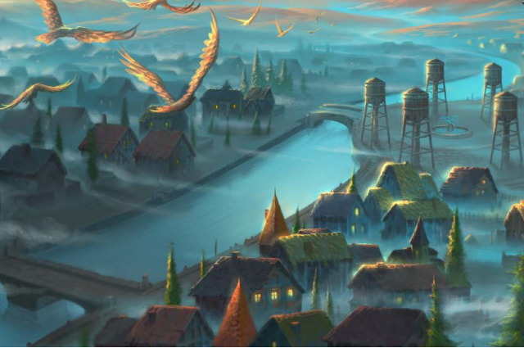

15. Tuskhead Stoneworking
A new venture in the last decade, Tuskhead Stoneworking does brisk business building limestone foundations and walkways, installing landscaping stonework, and carving gravestones. The business is known for importing large barges of quarried stone straight into its building on the banks of Breach Creek, and management’s strong relationship with the town council has ensured that all permit requests are readily approved. In recent years, Tuskhead has poached a few prominent clients from the Posandi Bros. masonry company—a coup for owner Rorsk Axebane (male dwarf mason), who has always suspected that his rivals dabble in shady business practices.

16. Vusker’s Carts & Wheels
Located just inside the Breachill town limits, Vusker’s Carts & Wheels is the go-to wainwright for the many traveling merchants and adventuring caravans that pass through the town. Chief wainwright and business owner Fadelby Vusker (male human wainwright) is clever and hardworking, and he has built up a robust business from the small mom-and-pop store that his father opened just before he was born.

17. Wizard’s Grace
Owing to its proximity to Breachill Town Hall, the Wizard’s Grace tavern is the favored establishment of many adventurers who hope to gain work from the council by attending the town’s monthly Call for Heroes. Adventurers and municipal workers regularly mingle here, exchanging stories and generally enjoying the atmosphere created by the diverse clientele. In the days leading up to each council meeting, the tavern is particularly busy, as adventurers schmooze with town officials and even the occasional council member who might show up for a drink and a meal. Before each meeting, the inn’s tavern has a long-standing tradition of holding toasts and serving meals of boar stew with lentils—a practice owner Trinil Uskwold (female human innkeeper) inherited from her grandfather, a prominent local adventurer who loved eating that meal before embarking on his own many daring journeys. Because of the politics of socializing here, the crowd tends to be both well-mannered and chatty, though occasionally a brash adventurer or two gets rowdy.

Adventurer’s Discount
Adventurers serve as lucrative sources of income for the business owners in Breachill—cash-laden heroes freshly returned from their quests are a well-known source of money for local artisans and crafters. To encourage adventurers to spend their money in town, Breachill offers an “adventurer’s discount” to any group that has established itself as capable and has the town’s best interests at heart.

